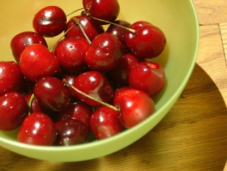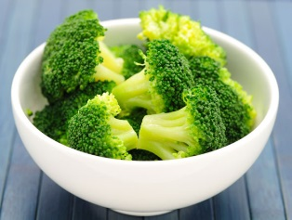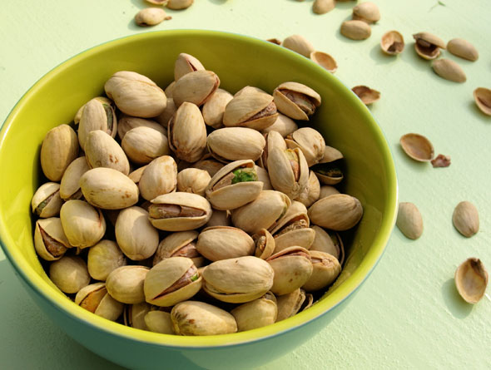

12 Best Foods For Arthritis
Although there is no diet cure for arthritis, certain foods have been shown to fight inflammation, strengthen bones and boost the immune system. Adding these foods to your balanced diet may help ease the symptoms of your arthritis.

Fuel Up on Fish
Because certain types of fish are packed with inflammation-fighting omega-3 fatty acids, experts recommend at least 3 to 4 ounces of fish, twice a week. Omega-3-rich fish include salmon, tuna, mackerel and herring.
Great for: rheumatoid arthritis

Step Up to Soy
Not a fan of fish but still want the inflammation-busting benefits of omega-3 fatty acids? Try heart-healthy soybeans (tofu or edamame). Soybeans are also low in fat, high in protein and fiber and an all-around good-for-you food.
Great for: rheumatoid arthritis

Opt for Oils
Extra virgin olive oil is loaded with heart-healthy fats, as well as oleocanthal, which has properties similar to non-steroidal, anti-inflammatory drugs. But it’s not the only oil with health benefits. Avocado and safflower oils have shown cholesterol-lowering properties, while walnut oil has 10 times the omega-3s that olive oil has.
Great for: rheumatoid arthritis, osteoarthritis

Check Out Cherries
Studies have shown cherries help reduce the frequency of gout attacks. Research has shown that the anthocyanins found in cherries have an anti-inflammatory effect. Anthocyanins can also be found in other red and purple fruits like strawberries, raspberries, blueberries and blackberries.
Great for: gout

Don’t Ditch the Dairy
Low-fat dairy products, like milk, yogurt and cheese are packed with calcium and vitamin D, both found to increase bone strength. Vitamin D is essential for calcium absorption, and it has been shown to boost the immune system. If dairy doesn't agree with you, aim for other calcium and vitamin D-rich foods like leafy green vegetables.
Great for: osteoporosis, osteoarthritis

Bet on Broccoli
Rich in vitamins K and C, broccoli also contains a compound called sulforaphane, which researchers have found could help prevent or slow the progression of osteoarthritis (OA). Broccoli is also rich in calcium, which is known for its bone-building benefits.
Great for: osteoarthritis

Go Green (Tea)
Green tea is packed with polyphenols, antioxidants believed to reduce inflammation and slow cartilage destruction. Studies also show that another antioxidant in green tea called epigallocatechin-3-gallate (EGCG) blocks the production of molecules that cause joint damage in people with rheumatoid arthritis (RA).
Great for: osteoarthritis, rheumatoid arthritis

Sink into Some Citrus
Citrus fruits – like oranges, grapefruits and limes – are rich in vitamin C. Research shows that getting the right amount of vitamin aids in preventing inflammatory arthritis and maintaining healthy joints with osteoarthritis (OA).
Great for: rheumatoid arthritis, osteoarthritis

Go with the Grain
Whole grains lower levels of C-reactive protein (CRP) in the blood. CRP is a marker of inflammation associated with heart disease, diabetes and rheumatoid arthritis. Foods like oatmeal, brown rice and whole-grain cereals are excellent sources of whole grains.
Great for: rheumatoid arthritis

Break Out the Beans
Beans are packed with fiber, a nutrient that helps lower CRP. Beans are also an excellent – and inexpensive – source of protein, which is important for muscle health. Some beans are rich in folic acid, magnesium, iron, zinc and potassium, all known for their heart and immune system benefits. Look for red beans, kidney beans and pinto beans.
Great for: rheumatoid arthritis

Grab the Garlic
Studies have shown that people who regularly ate foods from the allium family – such as garlic, onions and leeks – showed fewer signs of early osteoarthritis (OA). Researchers believe the compound diallyl disulphine found in garlic may limit cartilage-damaging enzymes in human cells.
Great for: osteoarthritis

Nosh on Nuts
Nuts are rich in protein, calcium, magnesium, zinc, vitamin E and immune-boosting alpha linolenic acid (ALA), as well as filling protein and fiber. They are heart-healthy and beneficial for weight loss. Try walnuts, pine nuts, pistachios and almonds.
Great for: osteoarthritis, rheumatoid arthritis

