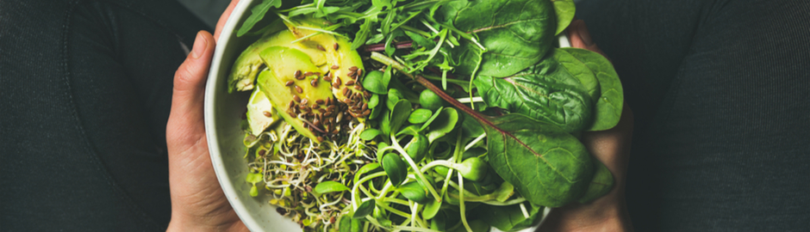
Living With Arthritis Blog | Tuesday, October 3, 2017
Can “Clean Eating” Help Arthritis Symptoms?
“Clean eating means different things to different people, and the “eat clean” catchphrase can be misinterpreted. “It implies that anything but the most pristine food is bad for us,” says registered dietitian Kim Larson, a spokesperson for the Academy of Nutrition and Dietetics, “but none of us eats a perfect diet.” But while the trend and the catchphrase are fairly new, the philosophy is not, and experts generally agree on the basics: Eating a diet of mostly whole, unprocessed foods and avoiding their highly refined, processed counterparts promotes health and well-being and is a good foundation for an arthritis diet. Some interpretations emphasize organic foods, avoiding genetically modified ingredients, eating more frequent, smaller meals, or “detoxing” with so-called “cleanses.” Here are some clean-eating principles dietitians say you can get behind – or skip.
Go for the whole. Whole, minimally processed foods such as produce, beans, nuts and grains are rich sources of fiber and antioxidants, while highly refined foods such as white bread and white rice have been stripped of the good stuff. Fiber and antioxidants are good for anyone, but might be particularly relevant for arthritis since studies show that both have anti-inflammatory properties.
Skip processed foods. Highly refined, processed foods are lacking in nutrients and often come with added sugars and unhealthy fats that have been linked to increased inflammation. “Excess sugars and refined carbs are the things we really need to limit to control inflammation,” Larson says.
Don’t assume you must go organic. An organic diet may help the environment, but it isn’t necessary to eat a strictly organic diet to eat clean, especially when it comes to fruits and vegetables. The traces of pesticides left behind on conventionally grown produce are well below the levels known to cause health problems, and broadly speaking, nonorganic produce is just as nutritious as organic, Larson says. “Nutrient-wise, they really are the same.”
Don’t detox. Detox diets and cleanses are often mentioned in the same breath as clean eating, but you don’t need to “detox” or go on an all-juice cleanse. “We have a liver and kidneys that clean things up for us just fine, “Larson says. In fact, she discourages detox diets and cleanses, which she says can upset the balance of good bacteria in the gut.
The verdict: Focus on adding more on fresh and whole foods and cutting out processed options, and don’t get hung up on fads. “A really good way to reset is to get off refined sugar and refined carbs. They don’t add any nutrients or health benefits,” Larson says. “To me, that’s clean eating.”
Author: KIRSTEN WEIR

