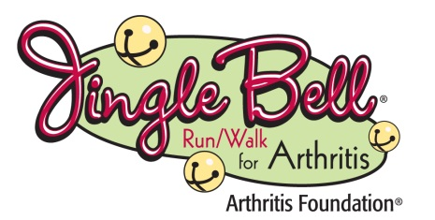

WHAT: Jingle Bell Run/Walk is the Arthritis Foundation’s annual holiday-themed event to raise awareness and funds to fight the nation’s leading cause of disability. Arthritis affects 50 million adults and 300,000 children. The disease claims the lives of nearly 10,000 people each year. The Jingle Bell Run/Walk provides funding for research, local programs and services and advocacy efforts that will improve the lives of people with arthritis.

WHEN: Registration begins at (TIME) and the Walk starts at (TIME) on (DATE)

WHERE: (LOCATION NAME) (ADDRESS)
To learn about the Arthritis Foundation Jingle Bell Run/Walk (COMMUNITY) please visit (LOCAL WEBSITE) (OR) www.arthritis.org/jbr.

AVAILABLE: Event opportunities include,
- Local honorees (NAMES, BRIEF DESCRIPTION)
- Local Arthritis Foundation representatives/medical experts
- Photographs with local honorees and participants
- Holiday-themed Costume Contest

WHY: The prevalence of arthritis or chronic joint symptoms is surging, currently affecting more approximately 50 million (one in five) Americans. By 2030, it is estimated that 67 million Americans will suffer from arthritis. Jingle Bell Run/Walk raises funds and awareness to help prevent, control and cure arthritis and related diseases.
CONTACT: (NAME, INFO)

